**Installation and use of AirSensEUR DEMO vs.1.0**

# License

AirSEnsEUR Demo is delivered as a freeware, it is made available free of charge. It is not copyrighted, there is no control of its distribution. Users are not allowed to modify it and sell it. It is distributed without its source code, thus preventing modification by users.

The Software is provided "as is" without warranty of any kind, either express or implied, including without limitation any implied warranties of condition, uninterrupted use, merchantability, fitness for a particular purpose, or non-infringement.

# Installation of AirSensEUR DEMO vs 1.0

1. The software was installed on Windows 7 and windows 8.
2. Run setup.exe in …\20151120 builds AirSensEURDemo\AirSensEUR Demo Installer\Volume
3. Choose destination directory both for AirSensEURDEMO application and National Instruments (NI) products. It is advised to choose the Program files directory for 32 bit applications (see example below with window 8.1)

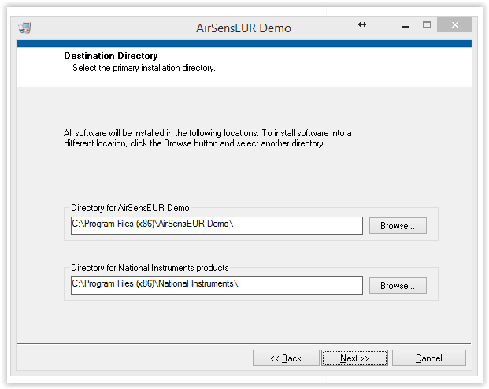

1. Accept the license agreement for the NI libraries

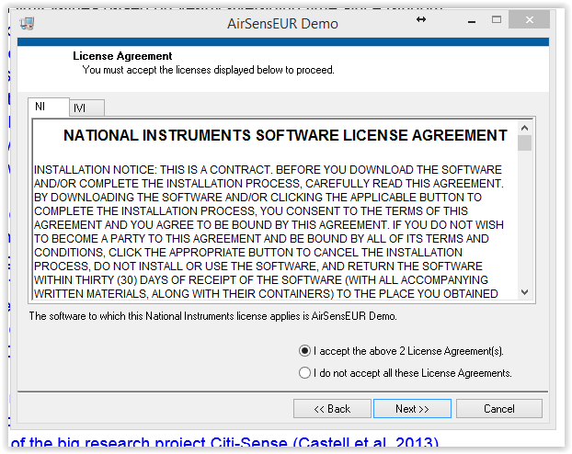

1. You get the following message when the software is installed:

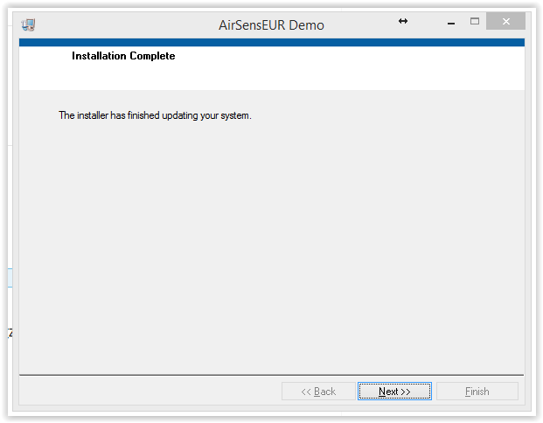

1. You need to re-boot your system to run AirSensEURDEMO:

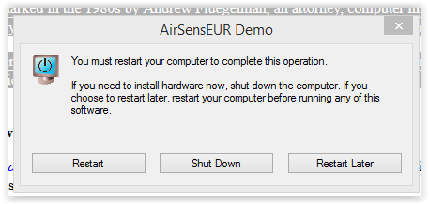

# Installation of AirSensEUR DEMO vs 1.0

1. Connect the daughter board of the AirSensEUR shield to the PC with a USB cable. Goes to device manager to detect the COM number of the serial port observe the COM number.
2. Run AirSensEURDemo.exe in C:\Program Files (x86)\AirSensEUR Demo (this link will depend on the directory chosne in Installation step 3 and your operative system).

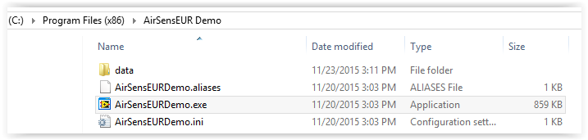

1. The following windows opens:

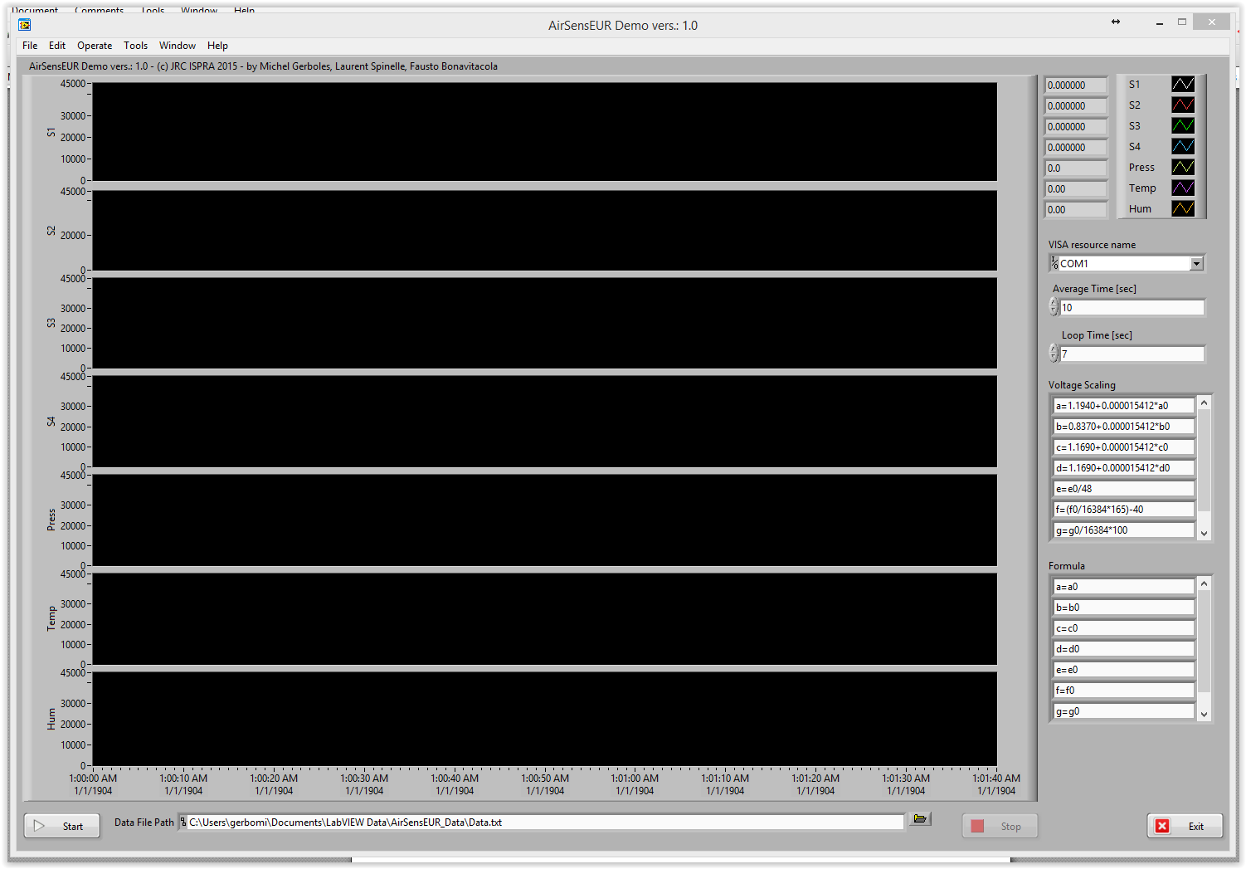

**1**

**2**

**3**

**4**

**5**

**6**

**7**

**12**

**8**

**10**

**9**

**11**

# Running AirSensEUR DEMO vs 1.0

1. Select the correct COM port
2. Select the directory and file name for the data file
3. Minimum data acquisition periodicity >= 7 sec
4. Minimum averaging time >= 10 sec
5. This are the equations for the conversion from analogic to digitally converted values to sensor voltages for the O3 E1F (S1), NO2 E50 (S2), NO E100 (S3) and CO E300 (S4) sensors (in this order) with the configuration parameters given in Gerboles M., et al, AirSensEUR: an open data/software /hardware multi-sensor platform for air quality monitoring. Part A: sensor shield, doi: 10.2788/30927, http://publications.jrc.ec.europa.eu/repository/handle/JRC97581
6. Use this equations for calibration of the sensors S1-S4. The parameters with 0 subscript, as for example a0, represents the values converted in point 5 for each channel. You can for example apply a correction of NO2 on O3 or apply a temperature, humidity correction.
7. Click to start the data acquisition
8. After a few averaging time, data will appear
9. The 7 graphs with start displaying (S1 to S4 are for the 4 sensors). These graphs behave as LabView graphs, you can right clicks the y-axis and change their layout.
10. You can also right click the x-axis to change the layout of the plots.
11. Click to stop data acquisition
12. Click to exit AirSensEUR DEMO